This task was developed by high school and postsecondary mathematics and design/pre-construction educators, and validated by content experts in the Common Core State Standards in mathematics and the National Career Clusters Knowledge & Skills Statements. It was developed with the purpose of demonstrating how the Common Core and CTE Knowledge & Skills Statements can be integrated into classroom learning – and to provide classroom teachers with a truly authentic task for either mathematics or CTE courses.

TASK: FENCES
TARGET COMMON CORE STATE STANDARD(S) IN MATHEMATICS:
N-Q.3 Choose a level of accuracy appropriate to limitations on measurement when reporting quantities.
G-MG.3 Apply geometric methods to solve design problems (e.g., designing an object or structure to satisfy physical constraints or minimize cost; working with typographic grid systems based on ratios).*
7.EE.3 Solve multi-step real-life and mathematical problems posed with positive and negative rational numbers in any form (whole numbers, fractions, and decimals), using tools strategically. Apply properties of operations to calculate with numbers in any form; convert between forms as appropriate; and assess the reasonableness of answers using mental computation and estimation strategies. (Example removed to conserve space.)
7.G.1 Solve problems involving scale drawings of geometric figures, including computing actual lengths and areas from a scale drawing and reproducing a scale drawing at a different scale.
7G.6 Solve real-world and mathematical problems involving area, volume and surface area of two- and three-dimensional objects composed of triangles, quadrilaterals, polygons, cubes, and right prisms.
TARGET STANDARDS FOR MATHEMATICAL PRACTICES
MP 1 Make sense of problems and persevere in solving them.
MP- 2 Reason abstractly and quantitatively.
MP- 3 Construct viable arguments and critique the reasoning of others.
MP-4 Model with mathematics.
MP-6 Attend to precision.
TARGET COMMON CORE STATE STANDARD(S) IN ELA/LITERACY:
RST.9-10.1 Cite specific textual evidence to support analysis of science and technical texts, attending to the precise details of explanations or descriptions.
RST.9-10.3 Follow precisely a complex multistep procedure when carrying out experiments, taking measurements, or performing technical tasks, attending to special cases or exceptions defined in the text.
RST.9-10.7 Translate quantitative or technical information expressed in words in a text into visual form (e.g., a table or chart) and translate information expressed visually or mathematically (e.g., in an equation) into words.
WHST.9-10.1 Write arguments focused on discipline-specific content.
WHST.9-10.4 Produce clear and coherent writing in which the development, organization, and style are appropriate to task, purpose, and audience.
TARGET CAREER AND TECHNICAL EDUCATION (CTE) KNOWLEDGE & SKILLS STATEMENTS:
ACC 01.01.01 Use basic math functions to complete jobsite/workplace tasks.
ACC01.01.02 Use geometric formulas to determine areas and volumes of various structures.
ACC 01.01.05 Use appropriate formulas to determine measurements of dimensions, spaces and structures.
ACC 03.01.03 Estimate resources/materials required for a specific project or problem.
ACPA06.01.01 Identify client requirements.
ACPA 06.01.03 Draw and sketch by hand to communicate ideas effectively.
RECOMMENDED COURSE:
Geometry, Integrated Math I, or Integrated Math II; Applications in Design & Pre-Construction
ADDITIONAL INSTRUCTIONS:
This task should be completed over an extended period of time, including some time for research of local prices and building codes.
* Modeling standards appear throughout the CCSS high school standards and are indicated by a star symbol (*).

About the Common Core State Standards in Mathematics
The Common Core State Standards (CCSS) for Mathematics are organized by grade level in grades K–8. At the high school level, the standards are organized by conceptual category (number and quantity, algebra, functions, geometry, and probability and statistics), showing the body of knowledge students should learn in each category to be college and career ready, and to be prepared to study more advanced mathematics. The Standards for Mathematical Practice describe ways in which developing student practitioners of the discipline of mathematics increasingly ought to engage with the subject matter as they grow in mathematical maturity and expertise throughout the elementary, middle and high school years. www.corestandards.org

About the Common Core State Standards in English Language Arts/Literacy
The Common Core State Standards (CCSS) for ELA/Literacy are organized by grade level in grades K–8. At the high school level, the standards are organized by 9-10 and 11-12 grade bands. Across K-12 there are four major strands: Reading, Writing, Speaking and Listening, and Language. The CCSS also include Standards for Literacy in History/Social Studies, Science, and Technical Subjects, with content-specific (Reading and Writing) literacy standards provided for grades 6-8, 9-10, and 11-12, to demonstrate that literacy needs to be taught and nurtured across all subjects. www.corestandards.org

About the Career Cluster Knowledge and Skill Statements
As an organizing tool for curriculum design and instruction, Career Clusters™ provide the essential knowledge and skills for the 16 Career Clusters™ and their Career Pathways. It also functions as a useful guide in developing programs of study bridging secondary and postsecondary curriculum and for creating individual student plans of study for a complete range of career options. As such, it helps students discover their interests and their passions, and empowers them to choose the educational pathway that can lead to success in high school, college and career. www.careertech.org/career-clusters/resources/clusters/architecture.html. Although not included in this template, all Clusters and Pathways have Foundational Academic Expectations and Essential Knowledge & Skills Statements, which, in some cases, overlap with the Common Core State Standards.

KEY TERMS

- Technical terms: ordinance, setback, city code
- Area
- Unit cost

FENCES – The Task
Mr. C’s family would like to add a pool to their backyard, but need to install a fence around the property, as required by their local ordinance. You are a consultant and must provide a proposal that takes into consideration the city ordinance, which says that a fence may be on the side and back property lines but must be set back from the front (street) property line by a minimum of 16 feet. The type of fence that the client has selected requires a post at each corner and every 8 feet between the corners. Two entry gates are to be included.

Details:
Lot Size: 72’ x 120’
Gate size: 48” wide
Materials: Cedar privacy fence (1” x 4” x 6’) with scallop edge
4’’ x 4’’ posts at 8’ on center
Two gates: 4’ wide and 5’ high (leaving 6” at both bottom and top of fence)
2” x 4” x 8’ horizontal supports (See diagram below)
Metal fasteners for the supports
4" x 4" post |  |  |  |  |  |  |  | 4" x 4" post
 | 2" x 4" x 8'
 | 2" x 4" x 8'

Quikrete to set the posts

Other Assumptions:
- This is a privacy fence, with no gaps between fence boards.
- One bag of Quikcrete supplies concrete for two holes, each 3’ deep.
- There will be two supports horizontally between each pair of posts. (See diagram)
- It is assumed that you will use two boxes of fasteners.

- Using the street setback per city code (a minimum of 16’), draw a scaled diagram of the fence project, determine the costs of the fencing and supplies needed from two local lumber yards, and put together a recommendation of which lumber yard would be the most cost effective. Provide your reasoning using the cost chart below and write a letter to the client identifying and explaining your recommendation.

 | Lumber Yard A |  |  | Lumber Yard B
 | # needed | Unit cost | Subtotals | # needed | Unit cost | Subtotals
Cedar slats (1”x 4’’ x 6’) |  | $ 1.66 |  |  | $ 1.78
Posts (4” x 4” x 8’) |  | $ 4.50 |  |  | $ 3.75
Supports (2” x 4” x 8’) |  | $ 1.45 |  |  | $ 1.50
Gate (48”) |  | $ 32.40 |  |  | $ 31.10
Boxes of Fasteners |  | $ 16.50 |  |  | $ 17.50
Quikrete Concrete Bag |  | $4.50 |  |  | $4.60
TOTAL

- Indicate on your diagram that you observed the minimum setbacks, the scale you used, and where the gates and posts will be placed.
- Explain any decisions or additional assumptions made to accomplish the bid in your letter to the client, including the level of precision in your measurements.
- What is the total area of the fenced in backyard? What would be the maximum number of square feet available for the pool and surrounding areas, based on your diagram of the fenced yard?
Source: Adapted from ResourceMap

FENCES – Possible Solution(s)

Primary Task: Students will have varying designs and plans for the house, yard, and fence project. Here is one basic example.

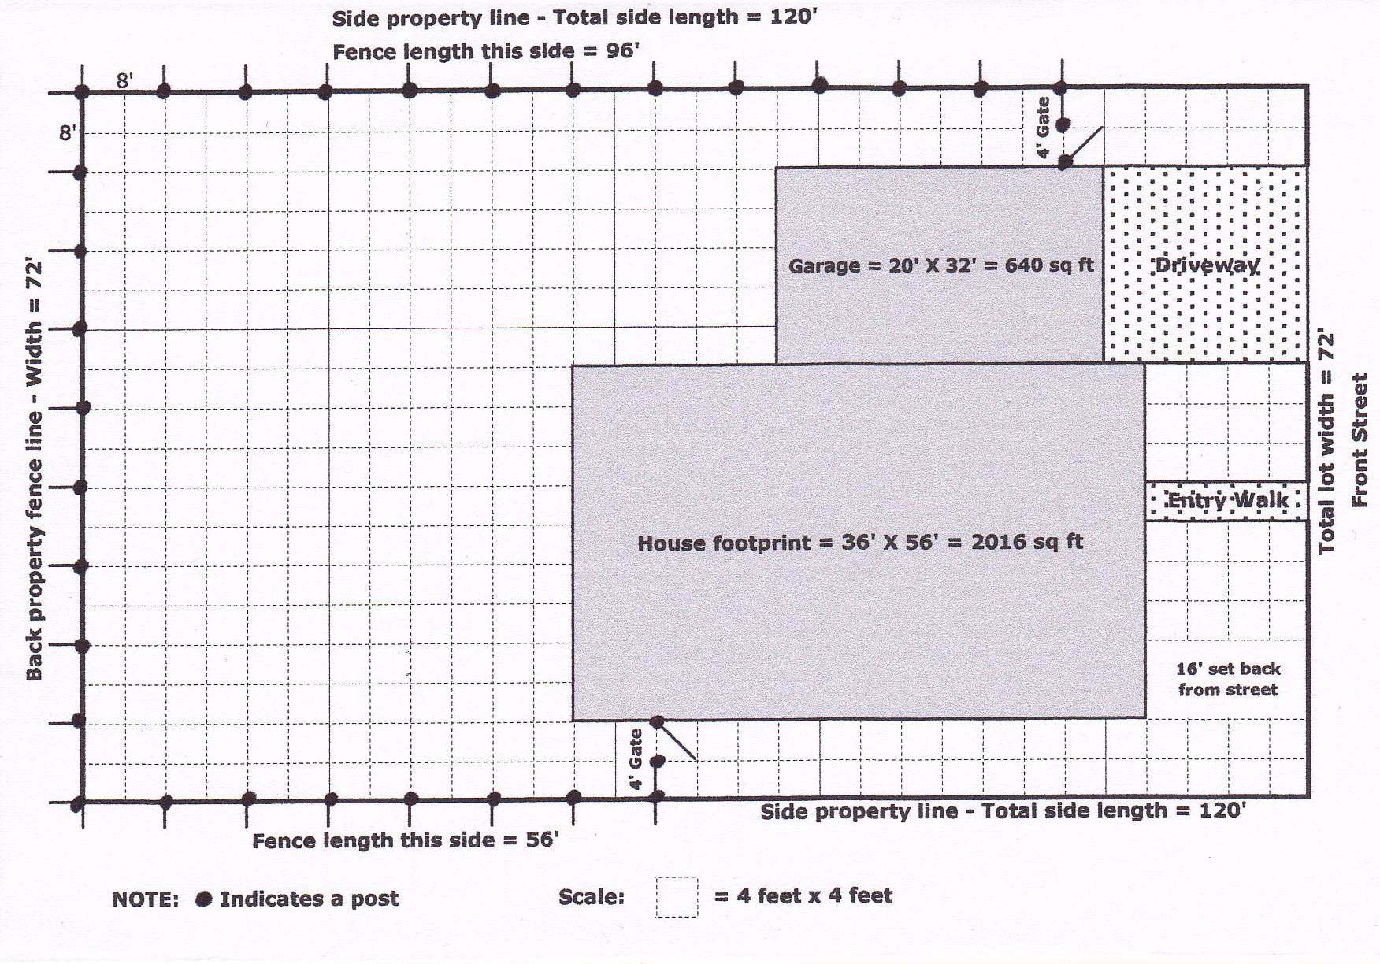

Total Fence length = 96 + 72 + 56 + 4 + 4 = 232 feet
Number of fence slats = 232 X 3 (@ 4" - 3 boards per foot) = 696
Number of posts = 33
Number of supports = 28 (8-ft spans) X 2 + 2 (for short sections near gates) = 58
Gates = 2
Boxes of fasteners = 2
Bags of Quikrete = 17
1.
 | Lumber Yard A |  |  | Lumber Yard B
 | # needed | Unit cost | Subtotals | # needed | Unit cost | Subtotals
Cedar slats (1”x 4’’ x 6’) | 696 | $ 1.66 | $1,155.36 | 696 | $ 1.78 | $1,238.88
Posts (4” x 4” x 8’) | 33 | $ 4.50 | $148.50 | 33 | $ 3.75 | $123.75
Supports (2” x 4” x 8’) | 58 | $ 1.45 | $84.10 | 58 | $ 1.50 | $87.00
Gate (48”) | 2 | $ 32.40 | $64.80 | 2 | $ 31.10 | $62.20
Boxes of Fasteners | 2 | $ 16.50 | $33.00 | 2 | $ 17.50 | $35.00
Quikrete Concrete Bag | 17 | $4.50 | $76.50 | 17 | $4.60 | $78.20
TOTAL |  |  | $1,562.26 |  |  | $1,625.03

- Setbacks are 24’ from the street on the left side of the house, when facing the street, and 64’ on the right. These measures meet the minimum setback code of 16’ from the front (street) lot line. (See diagram above.)

- Letters to the client will vary but might include such assumptions as the following:
- Lot measurements are not precise. Fence builders will know how to make adjustments.
- There should be extra slats since the posts will not be covered with fencing.
- There will be one-half bag of extra Quikrete, which could be distributed in the postholes to avoid having to put it in a landfill.
- The setback is a minimum so for this diagram it was decided to setback the fence further for the best possible curb appeal.

- The total fenced backyard area is 4304 sq ft for this sample design.

48 x 72 = 3456 sq ft
28 x 20 = 560 sq ft
28 x 8 = 224 sq ft
8 x 8 = 64 sq ft

3456 + 560 + 224 + 64 = 4304 sq ft total

The total above includes access sections, which are unlikely to be used for the pool or surrounding areas. This sample design would use the biggest open part of the fenced backyard for the pool, a total of 3456 square feet.

C

FENCES – Possible Extensions
The extensions below represent potential ways in which mathematics and/or CTE teachers can build on the task above. All of the extensions are optional and can be used in the classroom, as homework assignments, and/or as long-term interdisciplinary projects.

Extensions related to the fence:

- Calculate the materials needed and costs to stain or paint the fence.
- Use technology such as Google Sketch Up or CAD for design work or Microsoft Excel as a bidding tool.
- Create scale models of the design.
- Research city codes or ordinances in your area affecting fence design. How would different ordinances affect the design?
- Based on price, longevity, and stability, student must identify which fencing material is best for the project and defend his/her answer in a mock client presentation.

Extensions related to the pool: Now the customer would like assistance with the pool. Considerations are an ordinance that requires the pool is then set back 4’ from the fence.

- Use local codes determine the maximum size of the pool.
- Determine the cost of building the pool with certain budget and/or design constraints.
- Calculate the volume of the pool in gallons with an 8 foot maximum depth, sloped from a 3 foot minimum depth.
- Calculate the time it would take to fill the pool at, say, 42 gallons per minute.
- The builder needs the section between the pool and the fence to be filled in with concrete. Determine how much concrete (cubic yards) is needed for the job and determine the total cost.

.

FENCES – Appendix: Alignment Ratings

The rating system used in the following charts is as follows:
3 EXCELLENT ALIGNMENT:
The content/performance of the task is clearly consistent with the content/performance of the Common Core State Standard.

2 GOOD ALIGNMENT:
The task is consistent with important elements of the content/performance of the CCSS statement, but part of the CCSS is not addressed.

- WEAK ALIGNMENT:
There is a partial alignment between the task and the CCSS, however important elements of the CCSS are not addressed in the task.

N/A:
For Mathematical Practices a content rating does not apply.

In the charts C = Content Rating and P = Performance Rating

COLOR KEY
- Black = Part of CCSS/K&S Statement aligned to task
- Gray = Part of CCSS/K&S Statement not aligned to task

Task-to-Mathematical Practice Alignment Recording Sheet
Task Name | Aligned CCSS  Mathematical Practice Standards | C | P | Alignment Comments  (Standards selection, partial alignments, reasons for rating, etc.) | Task Comments  (Strengths, weaknesses, possible improvements, effectiveness, etc.)
FENCES | MP – 1 Make sense of problems and persevere in solving. | N/A | 3 | For this task students analyze givens, constraints, relationships, and goals. They must make conjectures about the form and meaning of the solution and plan a solution pathway. They must check the reasonableness of their solution, continually asking themselves, “Does this make sense?” | This is a multi-stage problem with real life applications and considerations. Students must identify measurements and lengths to determine costs, using both abstract reasoning and quantitative calculations.
 | MP – 2 Reason abstractly and quantitatively | N/A | 3 | This task involves quantitative relationships. It requires that students make sense of quantities and their relationships in the problem situation. They must attend to the meaning of the quantities and pay attention to units as they represent the quantities and measures in a table and then translate in a report to the client.
 | MP – 3 Construct viable arguments and critique the reasoning of others | N/A | 2 | Students are required to justify their conclusions. There is no requirement to critique the reasoning of others
 | MP –4 Model with mathematics | N/A | 3 | This task is an application from everyday life requiring that the student create a mathematical representation (model) that can replace the situation described in the prompt. Students must identify important quantities in the practical situation and use them to answer the questions posed. Students are required to explain their decisions and assumptions.
 | MP – 6 Attend to precision | N/A | 3 | This task requires that students communicate precisely, organizing their information, as they show their mathematical thinking. Students must also attend to appropriate level of precision in their calculations.

Task-to-Common Core State Standards Alignment Recording Sheet
Task Name | Aligned CCSS  Content Standards | C | P | Alignment Comments  (Standards selection, partial alignments, reasons for rating, etc.) | Task Comments  (Strengths, weaknesses, possible improvements, effectiveness, etc.)
FENCES | N-Q.3 Choose a level of accuracy appropriate to limitations on measurement when reporting quantities. | 3 | 3 | There are several components in this task that require estimation and a realistic view of the precision possible in a large-scale project. The student must then report to the client and include an explanation of those limitations. | This task combines planning, design, calculating, comparing, and presentation with writing and using communication skills.
 | G-MG.3 Apply geometric methods to solve design problems (e.g., designing an object or structure to satisfy physical constraints or minimize cost; working with typographic grid systems based on ratios).* | 3 | 3 | This requirement is key to this task. It is an application of a geometric design.
 | 7.EE.3 Solve multi-step real-life and mathematical problems posed with positive and negative rational numbers in any form (whole numbers, fractions, and decimals), using tools strategically. Apply properties of operations to calculate with numbers in any form; convert between forms as appropriate; and assess the reasonableness of answers using mental computation and estimation strategies. (Example removed to conserve space.) | 2 | 3 | The task requires operations with rational numbers but does not use negative numbers. This CCSS identifies a foundational skill required in the task.
 | 7.G.1 Solve problems involving scale drawings of geometric figures, including computing actual lengths and areas from a scale drawing and reproducing a scale drawing at a different scale. | 3 | 2 | A scale drawing is required as a diagram. There is no requirement to reproduce at another scale. This CCSS identifies a foundational skill required in the task.
 | 7.G.6 Solve real-world and mathematical problems involving area, volume and surface area of two- and three-dimensional objects composed of triangles, quadrilaterals, polygons, cubes, and right prisms. | 2 | 3 | This task does not require volume or surface area of three-dimensional objects
* Modeling standards appear throughout the CCSS high school standards and are indicated by a star symbol (*).

Task-to-National Career Cluster Knowledge & Skills Statements Alignment Recording Sheet
Task Name | Aligned Cluster/Pathway Knowledge/Skill | C | P | Alignment Comments  (Standards selection, partial alignments, reasons for rating, etc)
FENCES | ACC 01.01.01 Use basic math functions to complete jobsite/workplace tasks. | 3 | 3
 | ACC01.01.02 Use geometric formulas to determine areas and volumes of various structures. | 3 | 3 | Task requires geometric calculations that comply with statement.
 | ACC 01.01.05 Use appropriate formulas to determine measurements of dimensions, spaces and structures. | 2 | 3
 | ACC 03.01.03 Estimate resources/materials required for a specific project or problem. | 3 | 3 | The task requires students to describe how to get the least expensive solution.
 | ACPA06.01.01 Identify client requirements. | 3 | 3 | The task requires the proposal to include client specifications and compliance with city regulations.
 | ACPA 06.01.03 Draw and sketch by hand to communicate ideas effectively. | 3 | 3 | Students must draw a sketch by hand.

